**Lab 4-1: Analysis of Balance Perturbation Using a Force Plate**

**Introduction:**

For this lab, we investigated how various body movements affect balance using the force plate and Optitrack motion capture cameras. The goal of this lab was to understand how to use force plates in investigating balance. In each segment of the experiment, except for A, the subject’s balance is disturbed by either internal or external stimuli, in order to observe how the body maintains balance while dealing with internal and external stimuli. The main formulas used in this lab were Forces = (T*RawData)/0.04 where the transformation matrix T was:

| 2.9235 | .0089 | .0083 | -.0180 | -.0425 | .0273 |
| --- | --- | --- | --- | --- | --- |
| .0093 | 2.9310 | .0033 | .0075 | -.0157 | -.0217 |
| .0131 | .0234 | 11.5395 | .0057 | .0321 | .0268 |
| .0002 | .0002 | .0066 | 1.2722 | -.0010 | -.0118 |
| .0003 | -.0003 | .0016 | -.0010 | 1.2695 | -.0055 |
| -.0048 | .0021 | .0008 | -.0057 | -.0057 | .5898 |

Xp (the x center of pressure) = (-My)/(Fz), Yp (the y center of pressure) = (-Mx)/(Fz), and Tz (torque about z axis) = Mz - Xp*Fy+Yp*Fx.

**Materials:**

* Force Plate
* Optitrack Motion Capture System
* 39 Motion Capture Markers in the conventional positions

**Methods:**

This lab procedure involved several tasks to assess balance and stability in subjects:

A. Standing with feet side by side, arms crossed, and eyes closed on a force plate for 10 seconds.

B. Standing with feet together, arms at sides, eyes open, and leaning in all directions without bending the body for 15 seconds.

C. Standing with feet together, arms at sides, eyes closed, and swinging arms as fast as possible from sides to in front until at 45 degrees, abruptly stopping to perturb balance for 6 seconds, repeated 5 times.

D. Standing with heel to toe, arms at sides, eyes closed, and swinging right arm out to the side until at 45 degrees, abruptly stopping to perturb balance for 6 seconds, repeated 5 times.

E. Standing with feet together, arms at sides, eyes closed, and a group member gently pushing on the subject's back without indication, to perturb balance for 6 seconds, repeated 5 times.

Each task disturbed the subject's balance in different ways while recording data to analyze their stability responses**.**

**Results:**

**Part A:**

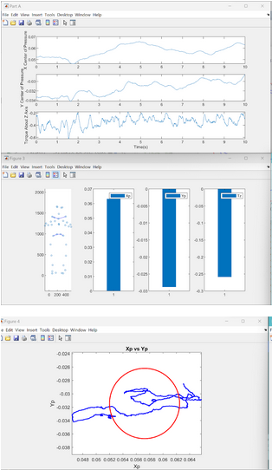

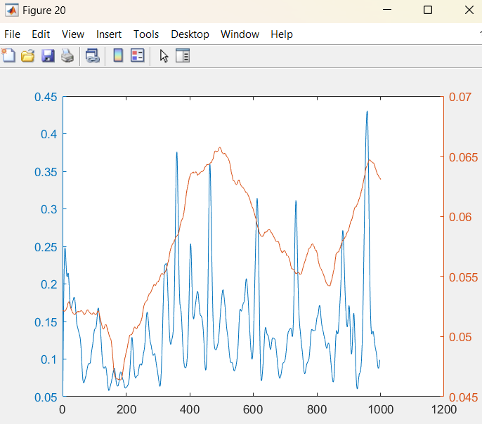

This trial was a control, and involved the subject standing still. First the data was processed with the low pass butterworth filter, using a cutoff frequency of 50 Hz that was determined using signalAnalyzer’s Power vs Frequency graph. The filter used was low pass, because the subject’s movements are much slower than something like an electrical signal. Next was calculating the center of pressure along the X and Y axes, as well as finding the torque about the Z axis. Then was the mean and standard deviation of the X and Y coordinates of the center of pressure for each trial. We generated subplots seen here which show Xp, Yp, and Tz as separate plots vs. time.This plot illustrates the Xp vs Yp, as well as a circle representing the means of both Xp and Yp.

**Part B:**

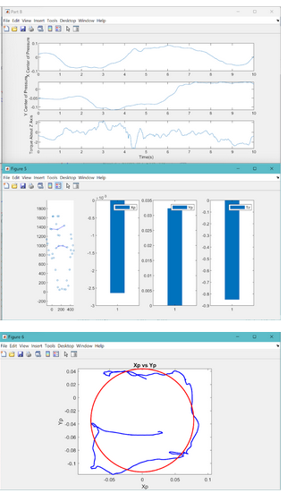

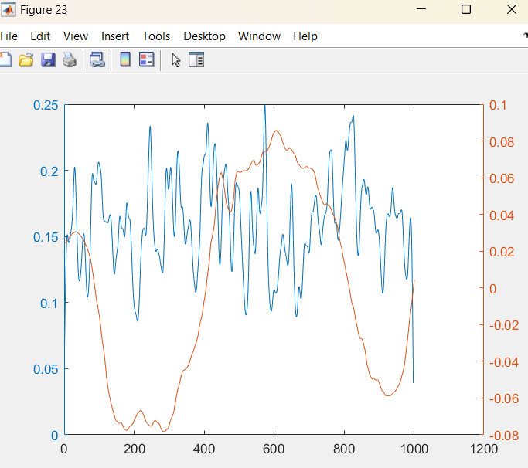

In this trial, the subject leaned in every direction, which was used to gauge the pressure used when they attempted to balance themselves. First the data was processed with the low pass butterworth filter, using a cutoff frequency of 50 Hz that was determined using signalAnalyzer’s Power vs Frequency graph. The filter used was low pass, because the subject’s movements are much slower than something like an electrical signal. Next was calculating the center of pressure along the X and Y axes, as well as finding the torque about the Z axis. Then was the mean and standard deviation of the X and Y coordinates of the center of pressure for each trial. We generated subplots seen here which show Xp, Yp, and Tz as separate plots vs. time. This plot illustrates the Xp vs Yp, as well as a circle representing the means of both Xp and Yp.

**Part C:**

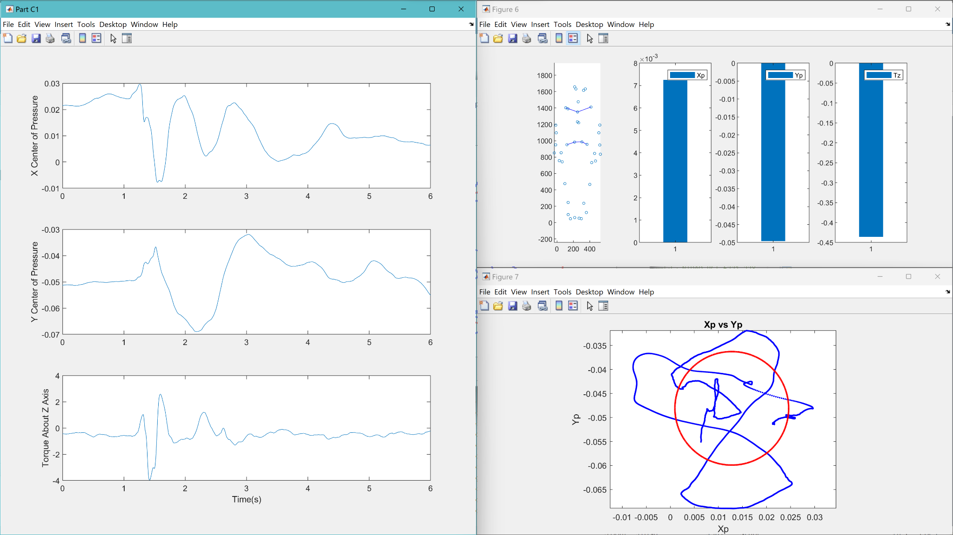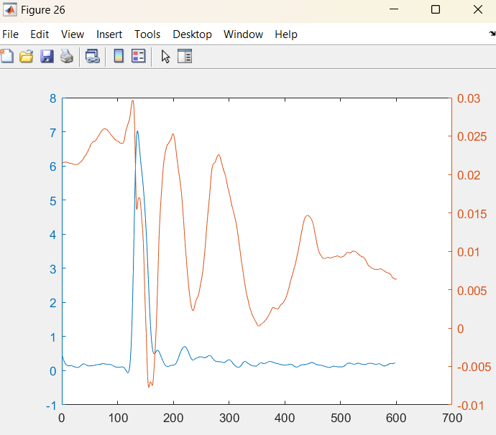

First the data was processed with the low pass butterworth filter, using a cutoff frequency of 50 Hz that was determined using signalAnalyzer’s Power vs Frequency graph. The filter used was low pass, because the subject’s movements are much slower than something like an electrical signal. Next was calculating the center of pressure along the X and Y axes, as well as finding the torque about the Z axis. Then was the mean and standard deviation of the X and Y coordinates of the center of pressure for each trial. We generated subplots seen here which show Xp, Yp, and Tz as separate plots vs. time. Due to the rapid arm movements seen in this trial, the subject initially had their balance disturbed, but returned to equilibrium after a brief correction. This plot illustrates the Xp vs Yp, as well as a circle representing the means of both Xp and Yp.

**Part D:**

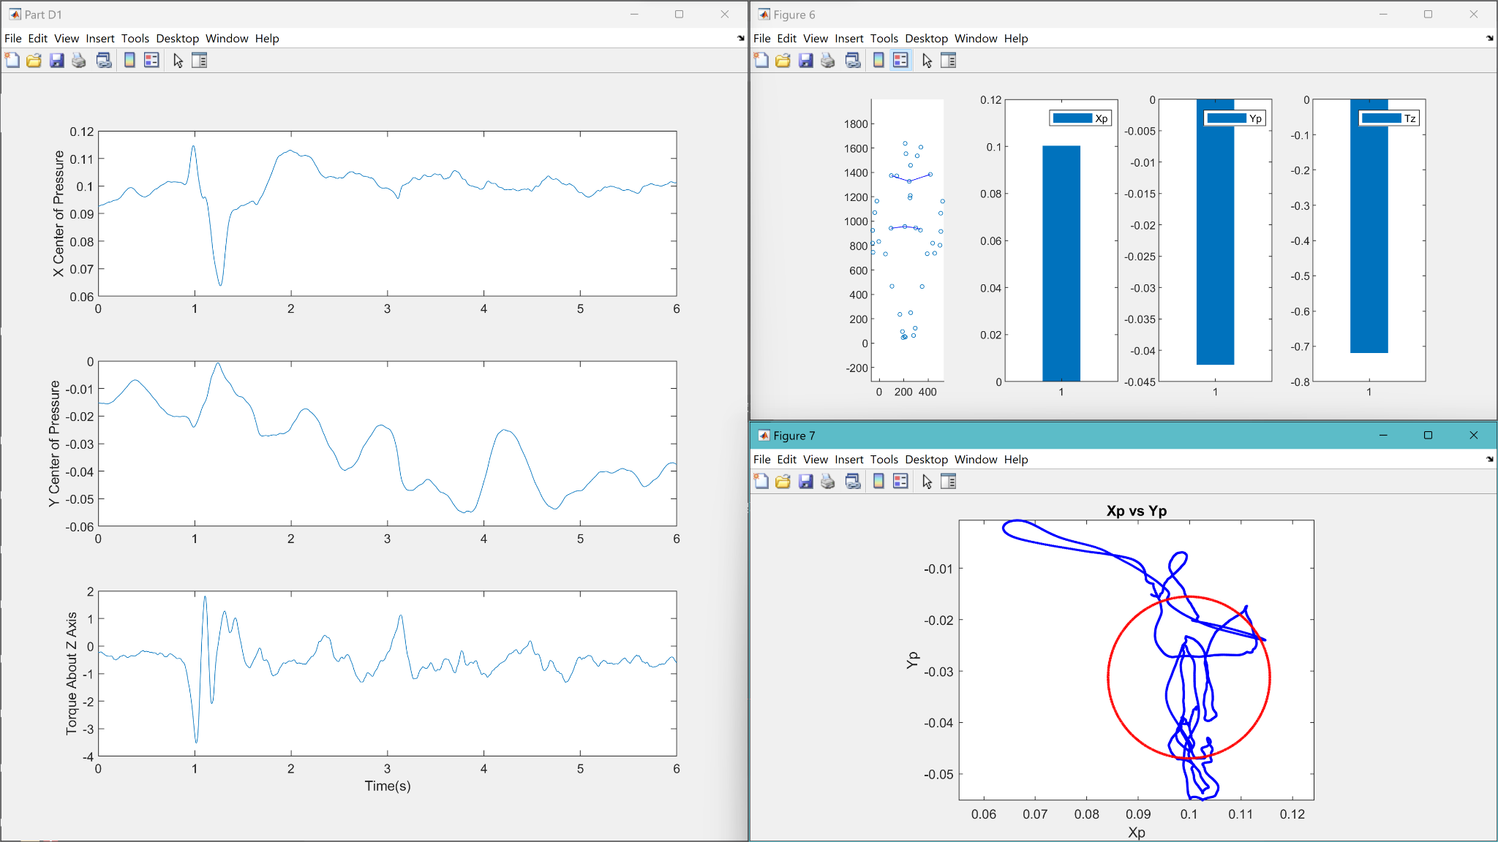

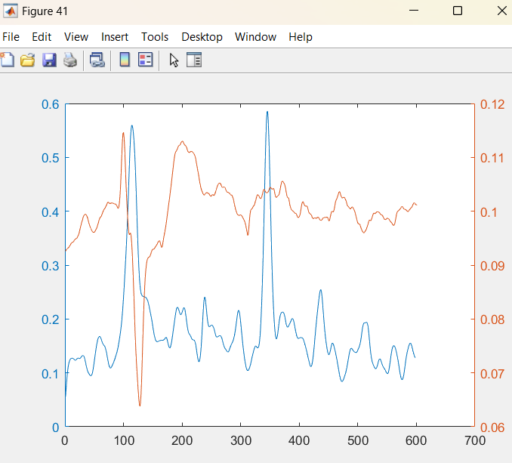

First the data was processed with the low pass butterworth filter, using a cutoff frequency of 50 Hz that was determined using signalAnalyzer’s Power vs Frequency graph. The filter used was low pass, because the subject’s movements are much slower than something like an electrical signal.

Next was calculating the center of pressure along the X and Y axes, as well as finding the torque about the Z axis.

Then was the mean and standard deviation of the X and Y coordinates of the center of pressure for each trial.

We generated subplots seen here which show Xp, Yp, and Tz as separate plots vs. time.

Due to the rapid arm movements seen in this trial, the subject initially had their balance disturbed, but returned to equilibrium after a brief correction.

This plot illustrates the Xp vs Yp, as well as a circle representing the means of both Xp and Yp.

**Part E:**

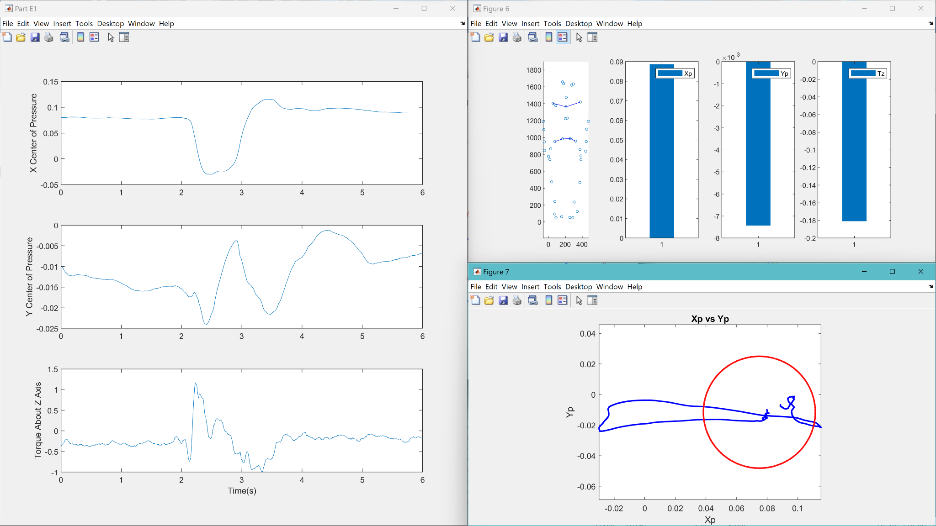

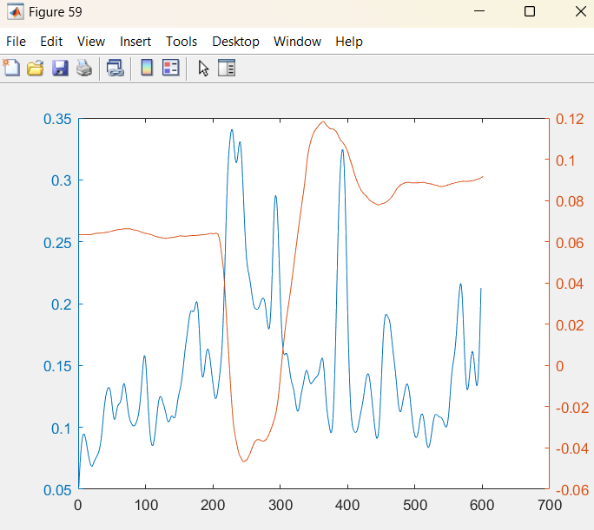

For this trial, the subject was pushed along the x axis unexpectedly while their eyes were closed. First the data was processed with the low pass butterworth filter, using a cutoff frequency of 50 Hz that was determined using signalAnalyzer’s Power vs Frequency graph. The filter used was low pass, because the subject’s movements are much slower than something like an electrical signal. Next was calculating the center of pressure along the X and Y axes, as well as finding the torque about the Z axis. Then was the mean and standard deviation of the X and Y coordinates of the center of pressure for each trial. We generated subplots seen here which show Xp, Yp, and Tz as separate plots vs. time. Due to the unexpected loading seen in this trial, the subject rapidly had to adjust their balance to avoid falling over, overcorrected, and then gradually returned to equilibrium. This plot illustrates the Xp vs Yp, as well as a circle representing the means of both Xp and Yp.

**Matlab code:**

**Main file:  
clc**

**clear**

**close all**

**[XpA, YpA, TzA, meanXpA, meanYpA, stdXpA, stdYpA]= parseNplot("Part A","Group1_BME384_rawdata_NIDAQ_PCI-6221_22859738.csv",'Group1_BME384_partA_NIDAQ_PCI-6221_22859738.csv',10001,10);**

**[XpB, YpB, TzB, meanXpB, meanYpB, stdXpB, stdYpB]= parseNplot("Part B", "Group1_BME384_rawdata_NIDAQ_PCI-6221_22859738.csv","Group1_BME384_partB_NIDAQ_PCI-6221_22859738.csv",10001,10);**

**[XpC1, YpC1, TzC1, meanXpC1, meanYpC1, stdXpC1, stdYpC1]= parseNplot("Part C1", "Group1_BME384_rawdata_NIDAQ_PCI-6221_22859738.csv","Group1_BME384_partC1_NIDAQ_PCI-6221_22859738.csv",6001,6);**

**[XpC2, YpC2, TzC2, meanXpC2, meanYpC2, stdXpC2, stdYpC2]= parseNplot("Part C2", "Group1_BME384_rawdata_NIDAQ_PCI-6221_22859738.csv","Group1_BME384_partC2_NIDAQ_PCI-6221_22859738.csv",6001,6);**

**[XpC3, YpC3, TzC3, meanXpC3, meanYpC3, stdXpC3, stdYpC3]= parseNplot("Part C3", "Group1_BME384_rawdata_NIDAQ_PCI-6221_22859738.csv","Group1_BME384_partC3_NIDAQ_PCI-6221_22859738.csv",6001,6);**

**[XpC4, YpC4, TzC4, meanXpC4, meanYpC4, stdXpC4, stdYpC4]= parseNplot("Part C4", "Group1_BME384_rawdata_NIDAQ_PCI-6221_22859738.csv","Group1_BME384_partC4_NIDAQ_PCI-6221_22859738.csv",6001,6);**

**[XpC5, YpC5, TzC5, meanXpC5, meanYpC5, stdXpC5, stdYpC5]= parseNplot("Part C5", "Group1_BME384_rawdata_NIDAQ_PCI-6221_22859738.csv","Group1_BME384_partC5_NIDAQ_PCI-6221_22859738.csv",6001,6);**

**[XpD1, YpD1, TzD1, meanXpD1, meanYpD1, stdXpD1, stdYpD1]= parseNplot("Part D1", "Group1_BME384_rawdata_NIDAQ_PCI-6221_22859738.csv","Group1_BME384_partD1_NIDAQ_PCI-6221_22859738.csv",6001,6);**

**[XpD2, YpD2, TzD2, meanXpD2, meanYpD2, stdXpD2, stdYpD2]= parseNplot("Part D2", "Group1_BME384_rawdata_NIDAQ_PCI-6221_22859738.csv","Group1_BME384_partD2_NIDAQ_PCI-6221_22859738.csv",6001,6);**

**[XpD3, YpD3, TzD3, meanXpD3, meanYpD3, stdXpD3, stdYpD3]= parseNplot("Part D3", "Group1_BME384_rawdata_NIDAQ_PCI-6221_22859738.csv","Group1_BME384_partD3_NIDAQ_PCI-6221_22859738.csv",6001,6);**

**[XpD4, YpD4, TzD4, meanXpD4, meanYpD4, stdXpD4, stdYpD4]= parseNplot("Part D4", "Group1_BME384_rawdata_NIDAQ_PCI-6221_22859738.csv","Group1_BME384_partD4_NIDAQ_PCI-6221_22859738.csv",6001,6);**

**[XpD5, YpD5, TzD5, meanXpD5, meanYpD5, stdXpD5, stdYpD5]= parseNplot("Part D5", "Group1_BME384_rawdata_NIDAQ_PCI-6221_22859738.csv","Group1_BME384_partD5_NIDAQ_PCI-6221_22859738.csv",6001,6);**

**[XpE1, YpE1, TzE1, meanXpE1, meanYpE1, stdXpE1, stdYpE1]= parseNplot("Part E1", "Group1_BME384_rawdata_NIDAQ_PCI-6221_22859738.csv","Group1_BME384_partE1_NIDAQ_PCI-6221_22859738.csv",6001,6);**

**[XpE2, YpE2, TzE2, meanXpE2, meanYpE2, stdXpE2, stdYpE2]= parseNplot("Part E2", "Group1_BME384_rawdata_NIDAQ_PCI-6221_22859738.csv","Group1_BME384_partE2_NIDAQ_PCI-6221_22859738.csv",6001,6);**

**[XpE3, YpE3, TzE3, meanXpE3, meanYpE3, stdXpE3, stdYpE3]= parseNplot("Part E3", "Group1_BME384_rawdata_NIDAQ_PCI-6221_22859738.csv","Group1_BME384_partE3_NIDAQ_PCI-6221_22859738.csv",6001,6);**

**[XpE4, YpE4, TzE4, meanXpE4, meanYpE4, stdXpE4, stdYpE4]= parseNplot("Part E4", "Group1_BME384_rawdata_NIDAQ_PCI-6221_22859738.csv","Group1_BME384_partE4_NIDAQ_PCI-6221_22859738.csv",6001,6);**

**[XpE5, YpE5, TzE5, meanXpE5, meanYpE5, stdXpE5, stdYpE5]= parseNplot("Part E5", "Group1_BME384_rawdata_NIDAQ_PCI-6221_22859738.csv","Group1_BME384_partE5_NIDAQ_PCI-6221_22859738.csv",6001,6);**

**%% Optitrack data**

**idle("Group1_BME384_partA.csv", 1000, XpA, YpA, TzA, stdXpA, stdYpA, meanXpA, meanYpA, 10001)**

**idle("Group1_BME384_partB.csv", 1000, XpB, YpB, TzB, stdXpB, stdYpB, meanXpB, meanYpB, 10001)**

**idle("Group1_BME384_partC1.csv", 600, XpC1, YpC1, TzC1, stdXpC1, stdYpC1, meanXpC1, meanYpC1, 6001)**

**idle("Group1_BME384_partC2.csv", 600, XpC2, YpC2, TzC2, stdXpC2, stdYpC2, meanXpC2, meanYpC2, 6001)**

**idle("Group1_BME384_partC3.csv", 600, XpC3, YpC3, TzC3, stdXpC3, stdYpC3, meanXpC3, meanYpC3, 6001)**

**idle("Group1_BME384_partC4.csv", 600, XpC4, YpC4, TzC4, stdXpC4, stdYpC4, meanXpC4, meanYpC4, 6001)**

**idle("Group1_BME384_partC5.csv", 600, XpC5, YpC5, TzC5, stdXpC5, stdYpC5, meanXpC5, meanYpC5, 6001)**

**idle("Group1_BME384_partD1.csv", 600, XpD1, YpD1, TzD1, stdXpD1, stdYpD1, meanXpD1, meanYpD1, 6001)**

**idle("Group1_BME384_partD2.csv", 600, XpD2, YpD2, TzD2, stdXpD2, stdYpD2, meanXpD2, meanYpD2, 6001)**

**idle("Group1_BME384_partD3.csv", 600, XpD3, YpD3, TzD3, stdXpD3, stdYpD3, meanXpD3, meanYpD3, 6001)**

**idle("Group1_BME384_partD4.csv", 600, XpD4, YpD4, TzD4, stdXpD4, stdYpD4, meanXpD4, meanYpD4, 6001)**

**idle("Group1_BME384_partD5.csv", 600, XpD5, YpD5, TzD5, stdXpD5, stdYpD5, meanXpD5, meanYpD5, 6001)**

**idle("Group1_BME384_partE1.csv", 600, XpE1, YpE1, TzE1, stdXpE1, stdYpE1, meanXpE1, meanYpE1, 6001)**

**idle("Group1_BME384_partE2.csv", 600, XpE2, YpE2, TzE2, stdXpE2, stdYpE2, meanXpE2, meanYpE2, 6001)**

**idle("Group1_BME384_partE3.csv", 600, XpE3, YpE3, TzE3, stdXpE3, stdYpE3, meanXpE3, meanYpE3, 6001)**

**idle("Group1_BME384_partE4.csv", 600, XpE4, YpE4, TzE4, stdXpE4, stdYpE4, meanXpE4, meanYpE4, 6001)**

**idle("Group1_BME384_partE5.csv", 600, XpE5, YpE5, TzE5, stdXpE5, stdYpE5, meanXpE5, meanYpE5, 6001)**

**parseNplot function:**

**function [Xp,Yp, Tz, meanXp,meanYp, stdXp, stdYp] = parseNplot(Part, filename1, filename2, framecount, spacing)**

**% T data**

**T=[2.9235 .0089 .0083 -.0180 -.0425 .0273**

**.0093 2.9310 .0033 .0075 -.0157 -.0217**

**.0131 .0234 11.5395 .0057 .0321 .0268**

**.0002 .0002 .0066 1.2722 -.0010 -.0118**

**.0003 -.0003 .0016 -.0010 1.2695 -.0055**

**-.0048 .0021 .0008 -.0057 -.0057 .5898];**

**FandM = readtable(filename1);**

**Data = table2array(FandM);**

**% find means**

**means = zeros(1,6);**

**for i = 5:10**

**means(i-4) = mean(Data(1:framecount,i));**

**end**

**PartA = readtable(filename2);**

**Adata = table2array(PartA);**

**PartAFandM = Adata(1:framecount,5:10) - means;**

**Time = linspace(0,spacing,framecount);**

**Forces = (PartAFandM*T')/0.04; % Converting To N*m**

**Fx = Forces(:,1);**

**Fy = Forces(:,2);**

**Fz = Forces(:,3);**

**Mx = Forces(:,4);**

**My = Forces(:,5);**

**Mz = Forces(:,6);**

**% i = 0;**

**% Filtering lol**

**SF = 1000;**

**order = 2;**

**Cutoff = 50/500;**

**[b, a] = butter(order, Cutoff, "low");**

**FilteredForces = zeros(framecount,6);**

**for i = 1:6**

**FilteredForces(:,i) = filtfilt(b, a, Forces(:,i));**

**end**

**FFx = FilteredForces(:,1);**

**FFy = FilteredForces(:,2);**

**FFz = FilteredForces(:,3);**

**FMx = FilteredForces(:,4);**

**FMy = FilteredForces(:,5);**

**FMz = FilteredForces(:,6);**

**Xp = (-FMy)./(FFz); %**

**Yp = (-FMx)./(FFz); %**

**Tz = (FMz)-(Xp).*(FFy)+(Yp).*(FFx); %**

**meanXp = mean(Xp); %**

**meanYp = mean(Yp); %**

**stdXp = std(Xp); %**

**stdYp = std(Yp); %**

**figure("NumberTitle","off","Name",Part)**

**subplot(3,1,1)**

**plot(Time,Xp)**

**ylabel('X Center of Pressure')**

**subplot(3,1,2)**

**plot(Time,Yp)**

**ylabel('Y Center of Pressure')**

**subplot(3,1,3)**

**plot(Time,Tz)**

**ylabel('Torque About Z Axis')**

**xlabel('Time(s)')**

**idle function:**

**function [accelmag, time] = idle(filename,endTime, Xp, Yp, Tz, stdXp, stdYp, meanXp, meanYp, lastframe)**

**global accelmag;**

**LottaData = readtable(filename);**

**Coords = table2array(LottaData);**

**Coords(1:4,:) = [];**

**TimePos = Coords(1:endTime,2);**

**Position = Coords(1:endTime,477:end);**

**Xcoords = Position(:,1:3:end);**

**Ycoords = Position(:,2:3:end);**

**Zcoords = Position(:,3:3:end);**

**frame = length(TimePos);**

**skipx = Xp(1:10:lastframe,:);**

**skipy = Yp(1:10:lastframe,:);**

**skipz = Tz(1:10:lastframe,:);**

**figure;**

**subplot(1,4,1)**

**hold on;**

**dude = plot3(Xcoords(1,:), Ycoords(1,:), Zcoords(1,:), 'o', 'MarkerSize', 3);**

**hip = line([Xcoords(1,21), Xcoords(1,30), Xcoords(1,12), Xcoords(1,4)], [Ycoords(1,21), Ycoords(1,30), Ycoords(1,12), Ycoords(1,4)], [Zcoords(1,21), Zcoords(1,30), Zcoords(1,12), Zcoords(1,4)], 'Color', 'b');**

**sternum = line([Xcoords(1,13), Xcoords(1,2), Xcoords(1,31)], [Ycoords(1,13), Ycoords(1,2), Ycoords(1,31)], [Zcoords(1,13), Zcoords(1,2), Xcoords(1,31)], 'Color', 'b');**

**axis equal;**

**subplot(1,4,2)**

**barHandlex = bar(skipx);**

**legend('Xp');**

**subplot(1,4,3)**

**barHandley = bar(skipy);**

**legend('Yp');**

**subplot(1,4,4)**

**barHandlez = bar(skipz);**

**legend('Tz');**

**for frame = 1:50:frame**

**% constantly plots frames**

**set(dude, 'XData', Xcoords(frame,:), 'YData', Ycoords(frame,:), 'ZData', Zcoords(frame,:));**

**set(hip, 'XData', [Xcoords(frame,21), Xcoords(frame,30), Xcoords(frame,12), Xcoords(frame,4)], 'YData', [Ycoords(frame,21), Ycoords(frame,30), Ycoords(frame,12), Ycoords(1,4)], 'ZData', [Zcoords(frame,21), Zcoords(frame,30), Zcoords(frame,12), Zcoords(frame,4)]);**

**set(sternum, 'XData', [Xcoords(frame,13), Xcoords(frame,2), Xcoords(frame,31)], 'YData', [Ycoords(frame,13), Ycoords(frame,2), Ycoords(frame,31)], 'ZData', [Zcoords(frame,13), Zcoords(frame,2), Xcoords(frame,31)]);**

**subplot(1, 4, 2);**

**set(barHandlex, 'YData', skipx(frame,:))**

**subplot(1, 4, 3);**

**set(barHandley, 'YData', skipy(frame,:))**

**subplot(1, 4, 4);**

**set(barHandlez, 'YData', skipz(frame,:))**

**drawnow; % Update the figure with new data**

**end**

**hold off;**

**figure;**

**plot(Xp, Yp, 'b.'); % Plotting Xp vs Yp**

**title('Xp vs Yp')**

**xlabel('Xp')**

**ylabel('Yp')**

**hold on;**

**theta = linspace(0, 2*pi, 10001);**

**radius = sqrt(stdXp^2 + stdYp^2);**

**xCircle = radius * cos(theta) + meanXp;**

**yCircle = radius * sin(theta) + meanYp;**

**plot(xCircle, yCircle, 'r-', 'LineWidth', 2);**

**axis equal**

**figure;**

**poositionX=Xcoords(1:endTime,8);**

**poositionY=Ycoords(1:endTime,8);**

**poositionZ=Zcoords(1:endTime,8);**

**velx = diff(poositionX);**

**vely=diff(poositionY);**

**velz=diff(poositionZ);**

**accelx=diff(velx);**

**accely=diff(vely);**

**accelz=diff(velz);**

**accelmag=sqrt(accelx.^2+accely.^2+accelz.^2);**

**time = linspace(1,endTime,600);**

**[b, a] = butter(2, 50/500, "low");**

**accelmag=filtfilt(b, a, accelmag);**

**yyaxis left**

**plot(1:endTime-2,accelmag)**

**hold on**

**lxp = length(Xp);**

**timelengthimadeup = endTime + 1;**

**yyaxis right**

**plot(1:timelengthimadeup,Xp(1:lxp/timelengthimadeup:lxp,1))**

**title('Acceleration of Hand Chart')**

**xlabel('time')**

**ylabel('Acceleration of Hand')**

**Discussion and Conclusion:**

In conclusion, our lab experiment revealed that when participants rebalanced with their eyes closed, they tended to overcorrect their position. However, the data analysis process presented several challenges. Given the extensive amount of data collected, it was laborious to manage and process the information efficiently. To mitigate this issue, we structured our code into multiple functions. Nevertheless, both the complexity of the coding tasks and the sheer volume of data required to run the analysis posed significant difficulties, largely due to limited programming expertise. Despite these challenges, the results obtained provide valuable insights into the effects of visual feedback on balance reestablishment. Further research with improved data processing techniques and larger sample sizes could potentially yield more accurate and insightful findings.